# Project Design Phase-II

|  |  |
| --- | --- |
| **Date** | 24 June 2025 |
| **Team ID** | LTVIP2025TMID53966 |
| **Project Name** | BookNest: Where Stories Nestle |
| **Mentor Name** | Dr Shaik Salma Begam |
| **Maximum Marks** | 4 Marks |

**Data Flow Diagram & User Stories**

**Data Flow Diagram (DFD)**

A Data Flow Diagram (DFD) visually represents how information flows within Shopez. It shows how data enters and leaves the system, what changes the information, and where data is stored.

**DFD:**

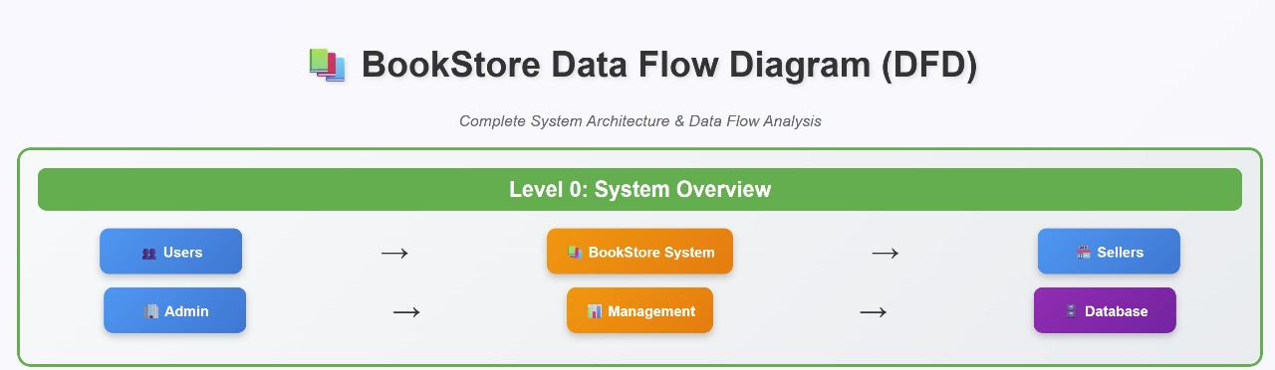

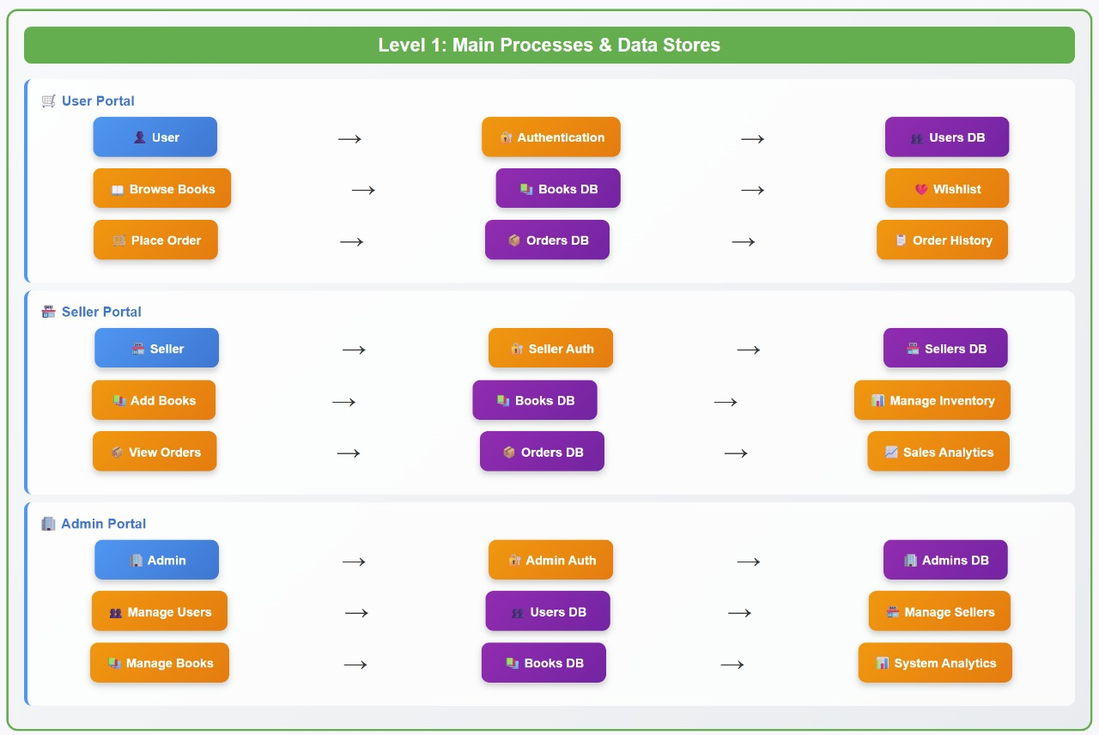

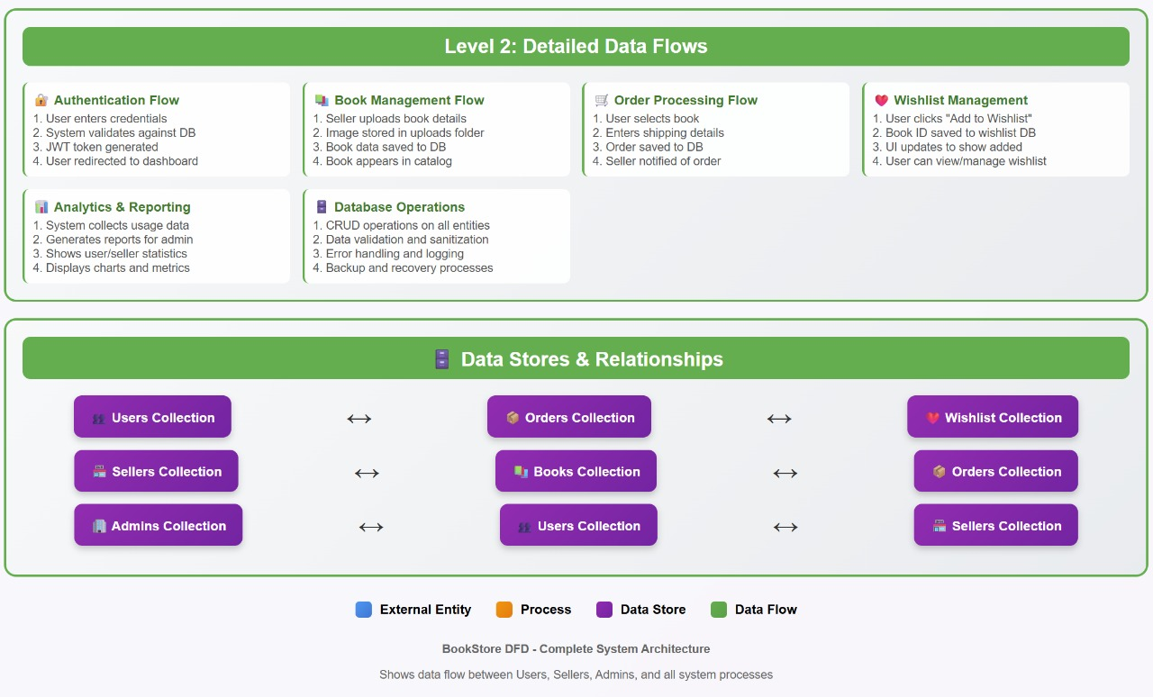

**Description:**

* Users place orders, which are processed and stored.
* Order processing generates invoices and collects payment.
* Shipping and fulfillment are managed, and users can track their orders.

**USER STORIES**

| **User Type** | **Functional Requirement (Epic)** | **User Story Number** | **User Story / Task** | **Acceptance Criteria** | **Priority** | **Release** |
| --- | --- | --- | --- | --- | --- | --- |
| Customer (Mobile/Web) | Registration | BN-US-1 | As a user, I can register for the application by entering my email, password, and confirming my password. | I can access my account/dashboard | High | Sprint-1 |
| Customer (Mobile/Web) | Registration Confirmation | BN-US-2 | As a user, I will receive a confirmation email or OTP once I register for the application. | I receive a confirmation email/OTP and can verify my account | High | Sprint-1 |
| Customer (Mobile/Web) | Login | BN-US-3 | As a user, I can log into the application using my email and password. | I can log in and access my dashboard | High | Sprint-1 |
| Customer (Mobile/Web) | Book Browsing & Search | BN-US-4 | As a user, I can browse books by genre and search by title/author. | I can view filtered and searched book results | High | Sprint-1 |
| Customer (Mobile/Web) | Cart & Order Placement | BN-US-5 | As a user, I can add or remove books to/from my cart and place an order. | I can manage my cart and receive an order confirmation | High | Sprint-2 |
| Customer (Mobile/Web) | View Order History & Tracking | BN-US-6 | As a user, I can view my past orders and track current deliveries. | I can see a list of past orders with tracking updates | Medium | Sprint-2 |
| Customer (Mobile/Web) | Invoice & Payment | BN-US-7 | As a user, I can view my invoice and complete secure payment for an order. | Invoice is generated and payment is processed securely | High | Sprint-2 |
| Administrator | Admin Book Management | BN-US-8 | As an admin, I can add, edit, or delete books from the catalog. | Admin can manage book data in real-time | High | Sprint-2 |
| Administrator | Admin User & Order Management | BN-US-9 | As an admin, I can manage users and view all customer orders. | Admin can view and control user/order data from the admin panel | High | Sprint-2 |
| Administrator | Banner Management | BN-US-10 | As an admin, I can manage homepage banners for promotions. | Admin can update promotional banners visible to customers | Medium | Sprint-3 |